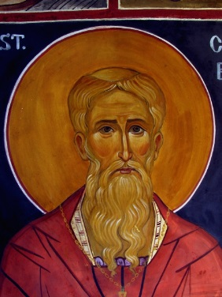
CACIQUE LEADERS

St. Cuthbert’s Way
Holy Trinity Episcopal Church
Scotland Pilgrimage 2017

Blue Team

1. May 20th | 2. May 21 | 3. May 22 | 4. May 23 | 5. May 24
Greg Farrand | Meredith Scott | Dottie Cooke | Sandy Hurt | Amy Klass
Ralph Shaw | Ben Thomas | Laura Gasiorek | Daphne Shaw | Trude McCarty
Peggy Glaser | Liz Blackwell | Stuart Gordon | Tom McCarty | Rob Payne
Freya Thomas | Tom Glaser | Todd Klass | Bill Drake | Claire Sullivan
Melissa Gordon | *Walk to Morebattle | *Walk to Kirk Yetholm | *Walk to Wooler | *Walk to Fenwick
*Walk to Harestanes

Red Team
1. May 21th | 2. May 22 | 3. May 23 | 4. May 24 | 5. May 25
Sarah Carver | David Horth | Betsey Horth | Dan Murray | Tim Marion
Michael Thomas | Meredith Barkley | Anna Buckner | Susan Storrs | Nancy Thornton
Ninevah Murray | Susan Griffin | Steffen Warberg | Virginia Wood | Tomoko Thornburg
 | Sally Marion | Sonya Schroeder | Kati Buckner | Lisa Talley
*Walk to Harestanes *Walk to Morebattle *Walk to Kirk Yetholm *Walk to Wooler *Walk to Fenwick

The walk to Lindisfarne for Blue Team will be led by Greg on May 25th
The walk to Lindisfarne for Red Team will be led by Nathan on May 26th

