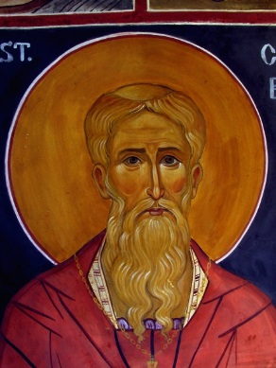
Roommate Assignments

St. Cuthbert Way
Holy Trinity Episcopal Church
Scotland Pilgrimage 2017

Blue Team

Liz Blackwell & Dottie Cooke
Greg Farrand & Bill Drake
Laura Gasiorek & Meredith Scott
Melissa & Stuart Gordon
Peggy & Tom Glaser
Sandy Hurt & Rob Payne
Amy & Todd Klass
Trude & Tom McCarty
Daphne & Ralph Shaw
Freya & Ben Thomas
Claire Sullivan

Red Team

Sarah Carver
Susan Griffin & Sonya Schroeder
Betsey & David Horth
Sally & Tim Marion
Ninevah & Dan Murray
Susan Storrs & Virginia Wood
Lisa Tally & Steffen Warberg
Michael Thomas & Meredith Barkley
Tomoko Thornburg & Nancy Thornton
AnnaBuckner&KatiBuckner

